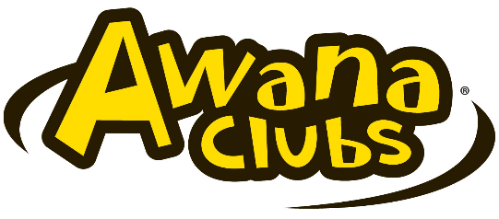
FBCR 2020-2021 CALENDAR SCHEDULE
Sundays 5:00-7:00PM

Date | AUGUST 2020 |  | Date | January 2021
2 | Pray for AWANA Clubs |  | 3 | Regular Club
9 | Pray for AWANA Clubs |  | 10 | Regular Club
16 | AWANA Clubs Registration Begins |  | 17 | Regular Club
23 | AWANA Clubs Preparation |  | 24 | Regular Club
30 | AWANA Clubs Preparation |  | 31 | Regular Club
Date | SEPTEMBER 2020 |  | DATE | February 2021
6 | NO AWANA CLUBS—Labor Day Weekend |  | 7 | NO AWANA CLUBS—Super Bowl
13 | AWARDS Drive-In Ceremony |  | 14 | NO AWANA CLUBS—Valentine’s Day
20 | AWANA Online Kick-Off Night |  | 21 | Regular Club
27 | Regular Club |  | 28 | Regular Club
DATE | OCTOBER 2020 |  | DATE | MARCH 2021
4 | Regular Club |  | 7 | Regular Club
11 | Regular Club |  | 14 | Regular Club
18 | Regular Club |  | 21 | Regular Club
25 | Regular Club |  | 28 | NO AWANA CLUBS—Spring Break
DATE | NOVEMBER 2020 |  | DATE | APRIL 2021
1 | Regular Club  Re |  | 4 | NO AWANA Clubs—Easter Sunday
8 | Regular Club |  | 11 | Regular Club
15 | Regular Club |  | 18 | Regular Club
22 | Regular Club |  | 25 | Regular Club
29 | NO AWANA CLUBS--Thanksgiving
DATE | DECEMBER 2020 |  | DATE | May 2021
6 | Regular Club |  | 2 | Last AWANA Club
13 | Regular Club |  | 9 | NO AWANA CLUBS—Mother’s Day
20 | Regular Club |  | 16 | TBD—Awards Preparation Sunday
27 | NO AWANA CLUBS—Winter Break |  | 23 | AWANA Closing Ceremony/Celebration
 |  |  | 30 | Memorial Day Weekend

Notice: Schedule Subject to Change!

FBCR AWANA SCHEDULE DATES & REMINDERS
2020-2021

- There will be NO AWANA club nights for the following dates:

Labor Day Weekend September 6th
Thanksgiving Weekend November 29th
Christmas/Winter Break December 27th
Super Bowl Sunday February 7th
Valentine’s Day February 14th
Spring Break/Easter Sunday March 28th & April 4th
Mother’s Day May 9th
Awards Preparation Sunday May 16th

- Awards Ceremony Night & Celebration: May 23rd, 2021 @ 5PM

- This is a special celebration with certificates, awards, etc.
- Clubbers & families are invited to attend and fellowship!
- Time: 5:00-6:30pm
- Location: FBCR Sanctuary & Fellowship Hall (If not in person, we will do a drive-in ceremony)

- Parent/guardian general reminders:

- Please check-in/out as you drop or pick up your child for safety purposes.
- AWANA clubs begin at 5:00pm SHARP!
- Make sure your child has the uniform, bible & handbook needed for each club night.
- We want to encourage you as the parent/guardian to work with your child(ren) in reading & completing the weekly sections for each club night at HOME, so that each child can complete the book by the end of the year. Use the days that we are not meeting to work with your child and invest time in working with them to catch up and or complete the book(s). This partnership is very IMPORTANT to us as a club.
- To reach the goal of finishing the book & receiving awards at the end of the year, each child should complete club lesson/sections per week.
- Uniform & handbook will be issued after club dues have been received & each clubber completing the entrance requirements.
- For any club cancellations please check all the following: website page, email, text message, voicemail at home, other. Contact your club director for any information regarding your kid’s club.

Thanks for partnering with us and making the AWANA Clubs a fun & exciting experience for your child(ren)!

First Baptist Church of Rockville
Children’s Ministry

